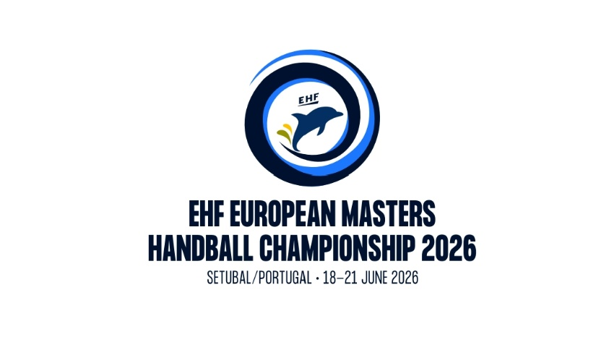

Registration Form

Please note: Each team must pay an entry fee of € 110 to the EHF.
Registrations only valid in connection with bank remittance!

Please fill in (capital letters) or mark correctly!

team name | country | Nr. players | Nr. active referees | Nr. welcome dinner participants

Contact person
Mobile *as well available during the Masters tournament

Email

Age category

Age check of players will be done by presenting an internationally valid passport at the venue! No extraordinary playing permissions will be granted! Health confirmation requested - to be presented by the accreditation/welcome desk.

Category born before Category born before
Men 35+ 31.12.1991 ☐ Women 33+ 31.12.1993 ☐
Men 45+ 31.12.1981 ☐ Women 43+ 31.12.1983 ☐
Men 50+ 31.12.1976 ☐
Men 55+ 31.12.1971 ☐
Men 60+ 31.12.1966 ☐

Confirmation
National Federation:

Date & Signature:

Please complete this form and return it to the EHF (brantl@eurohandball.com) and LOCS (europeumasterssetubal@gmail.com) by 27. 04. 2026 at the latest.

