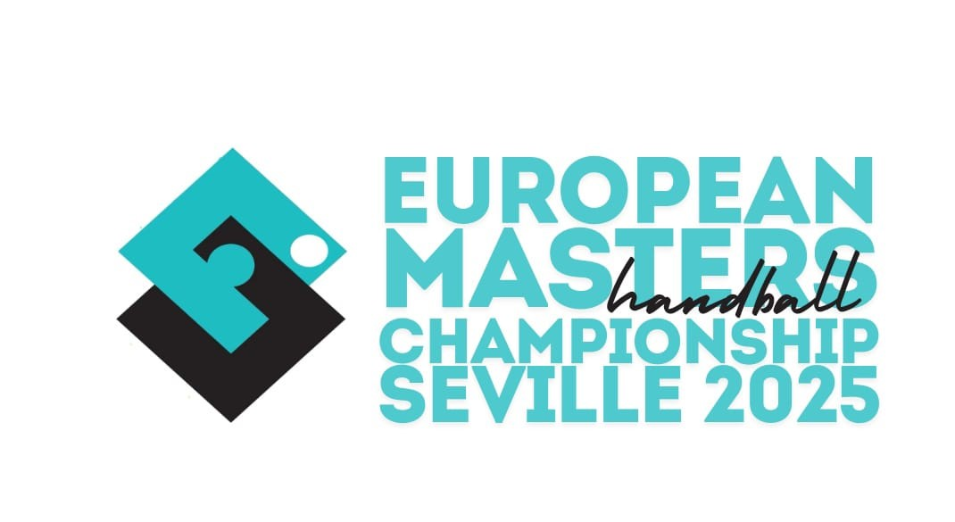
Registration Form

European Masters 2025 Handball Championships
June 19 - 22, 2025 / SEVILLA – Spain

Please note: Each team must pay a deposit payment of € 500 and an entry fee of € 110 to the EHF.
€ 500 will be refunded in case of participation in the 2025 Masters EChs.
Registrations only valid in connection with bank remittance!
General data
Please fill in (capital letters) or mark correctly!

team name | country | Nr. players | Nr. active referees | Nr. welcome dinner participants

Contact person
Mobile *as well available during the Masters tournament

Email

Age Category
Age check of players will be done by presenting an internationally valid passport at the venue! No extraordinary playing permissions will be granted! Health confirmation requested - to be presented by the accreditation/welcome desk.

Men 35+  (born before  31.12.1990) | Men 45+  (born before  31.12.1980) | Men 50+  (born before 31.12.1975) | Men 55+  (born before  31.12.1970) | Women 33+  (born before 31.12.1992) | Women 43+  (born before  31.12.1982)
□ | □ | □ | □ | □ | □

Confirmation
National Federation:

Date & Signature:

Please complete this form and return it to the EHF (brantl@eurohandball.com) and LOCS (info@euromasterhandballsevilla2025.com) by 28. 04. 2025 at the latest.

